Everyday Women of Sitka: Jeanne Wojcik

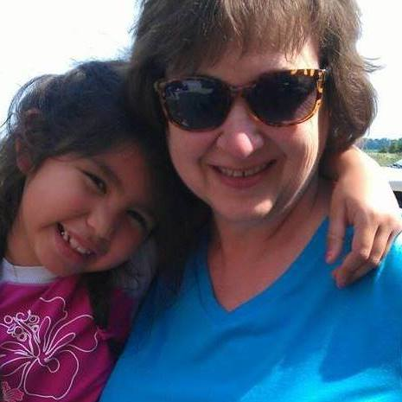

- Can you please tell me a little about yourself? How long have you lived in Sitka? What types of things are you involved in here?

My husband and I moved to Sitka in November, 2016, to be with our daughter Natalie and her family, She came here in 2009 after graduating from college and never came back home to Illinois except for vacations, so we moved to her when we retired. Since she is our only child, I had always told her to go where she wants when she grows up, and we would follow her when we could. Besides that, we were overdue for some adventure. I'm from southern Illinois, most recently from Troy, Illinois, a little town across the Mississippi River from St. Louis, Missouri. It's about the same size as Sitka, but close to quite a few other communities, both bigger and smaller. For instance, I had 3 Walmarts within 10 miles of my house and another 3 within 20 miles. I had worked for various insurance agencies and companies since 1976, and my latest job was managing a team of software testers at an insurance company in St. Louis. I was there for 16 years and worked for them remotely for a few months after I got here. Now, though, my Monday through Friday "job" is taking care of my 23 month old grandson and being here for my 10 year old granddaughter when she gets off school. They truly are an adventure and the best one I ever could have had.

- What is your biggest struggle right now?

Being so far away from my large extended family and the network of support they gave us was very difficult. I have 8 sisters and 5 brothers, and we've managed to stay close to each other even though our parents are gone. So not seeing any of them for over a year has been hard. Our first set of visitors is scheduled for end of May, so we are pretty excited. We're hoping we become a frequent vacation destination for them. My other struggle is helping my husband to cope with increasing mobility issues and chronic pain. He became disabled before we moved here, but the plane ride was extraordinarily tough on him.

- What does a normal "day in the life" look like for you?

I like getting up early, so being up bright and early for the kids isn't a problem. I get to do the things with little Auggie that I didn't get to do with his mom when she was little because I was doing then what she does now -- getting up and going to work outside the home. We have our routine of eat, play, nap, and then eat and play again. I am cooking much more than I used to which is making my husband pretty happy.

- What makes you proud to be a woman?

I'm proud to be a woman because women take a lot of responsibility for society. We bear children and continue the human race. In the very best scenario, we teach our young to be strong, capable, kind, fair and responsible.

- Do you have something you would like to say to other women in Sitka?

Love your families and remember that the positive example you set is invaluable.

