Everyday Women of Sitka: Kim Kirkness

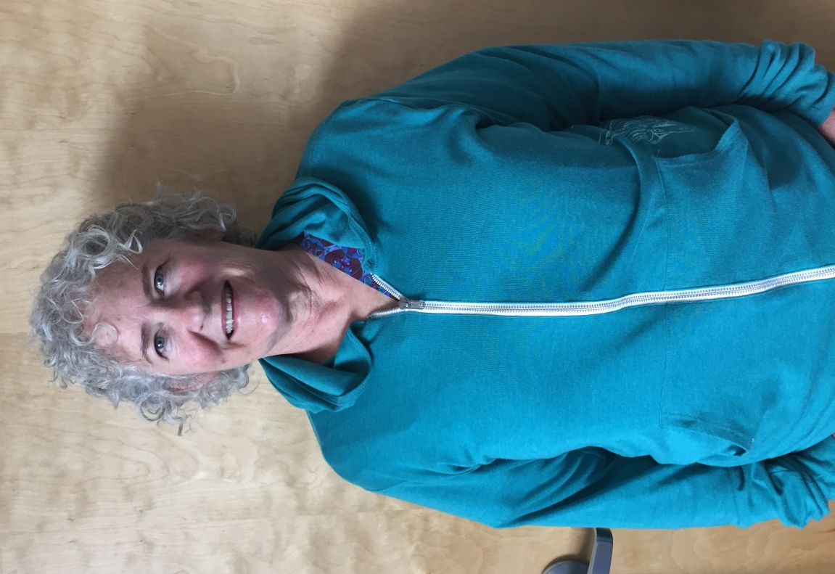

- Can you please tell me a little about yourself? How long have you lived in Sitka? What types of things are you involved in here?

I was born in Idaho, and lived there and in Montana for the first 50 years of my life. I developed a love for camping, hiking, skiing, biking, and most anything outdoors. I’m a wife, mother, grandmother, and a good friend. I’ve been in Sitka for 16+ years. I work as a nurse at SEARHC as the prenatal case manager. That means I get to meet and work with pregnant women in an office setting in all stages of pregnancy, up until they deliver. I originally wanted to be a midwife, and have a passion for working with women and families to help them have the best possible start to bringing their babies into the world. I worked in labor and delivery for many years, and now feel like I’m wrapping up my career in just the right spot.

- What is your biggest struggle right now?

My biggest challenge right now lies in the political climate. I’m very concerned that repealing the
Affordable Care Act will leave so many pregnant women and children without health care at a time when they are most vulnerable. I’m not convinced a plan that proposes having 23 million people lose their health care is a plan that is going to protect those who need it the most.

- What makes you proud to be a woman?

Women are so strong and enduring. I’ve seen some women come into their pregnancy in a pretty tough spot, and grow and pull their lives together. I’m amazed at the changes women can go through in this stage of life, and have in mind 2 women in particular who have gotten straight and sober and gone on to be great mothers. Services like SAFV are so critical to helping women as they go through tough times and need a lot of support to get their lives back on track.

- Who was/is a female role model for you? Why?

Role models are a hard one; there are so many to pick from. Mine range from the famous ones like Susan B. Anthony and Margaret Sanger, to so many women right here in Sitka. This includes the women honored by SAFV, the terrific nurses and physicians I’ve worked with over the years, the everyday women who live and work here contributing to this great community in many big and small meaningful ways.

- Why do you think you were nominated to be featured on our Facebook?

I really don’t know why I was nominated. I work primarily with women, and try to advocate for women. And I’ve long been a supporter of SAFV and the work done there helping women through what may be the most tumultuous times of their lives.

- What does a normal “day in the life” look like for you?

I like to get up early and have some quiet time to myself. I often read, check emails, and get on my exercise bike and do a little stretching, at least on the good days. I work at SEARHC with a great team coordinating care to pregnant women. During the summer I do a lot of gardening, some with a group of ladies where we take turns working on big projects in each other’s gardens, and I added some extra by getting on the Tree and Landscape Committee for the city. There has been an enormous amount of weeds in my life this summer! My husband and I are also blessed to have our son and daughter-in-law and 2 grandsons here in Sitka, and we are lucky enough to be an active part of their lives. Between work, family, a couple close friends, and pulling weeds, the outdoors and staying active, that’s it for me!

- Do you have something you’d like to say to other women in Sitka?

I hope that women in Sitka can work to build bridges in this time of polarization. If we can reach out to each other in our everyday lives, maybe we can help, in small every day actions, to remind ourselves we are all interconnected.

- What does being a strong woman mean to you?

Being a strong woman means to me relying on one another to make it through the hard times as well as the good ones. I’m a believer that asking for help is often a gift to the person being asked.

