Everyday Women of Sitka: Eleyna Rosenthal

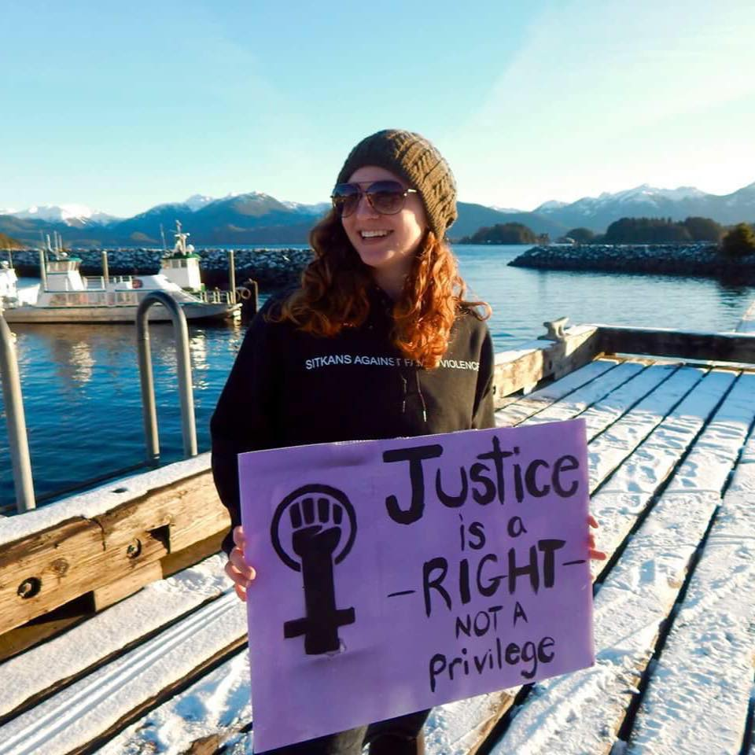

- Can you please tell me a little about yourself? How long have you lived in Sitka? What types of things are you involved in here?

I moved to Sitka about 2.5 years ago to do a year of service as an AmeriCorps VISTA with the SAFV shelter in the prevention department. It really sounded like the perfect fit. I was coming from the East Coast and ready to do something different and I really wanted to work with a group of people who were focused on female empowerment and safety. I think I really found that here in Sitka. It was only for a year, but I fell in love with Sitka and stayed. Now I am working at the Forest Service, but I still try to stay involved in the community in the same way I was able to at SAFV.

Regarding things I am involved with in Sitka, my longest commitment has been the roller derby team. It is super cool and not something I thought I would have the opportunity to do, but that is one of the reasons I love Sitka. It kind of presents things that would be difficult to find anywhere else. For example, I was living right near Washington D.C. before moving here and the closest roller derby team was about an hour away. It was super expensive, and there were a lot of barriers to being able to do those kinds of things. In Sitka, everything is accessible in a different kind of way. I just look online at the Raven Radio calendar and pick some event to attend that day. I get to explore different parts of my identity here both as an individual and a community member which was not really my intention in moving here, but something I am really grateful to find.

- What is your biggest struggle right now?

My major struggle right now has to do with the political climate: figuring out how to engage in the national dialogue while being so isolated here. It feels so isolated, I don’t know that it is as isolated as it feels. You see people gathering with like-minded individuals to protest one thing or another, and you can’t really do that so much in Sitka. There are things I feel really passionate about that are going on in the national dialogue, and I really struggle with how to find meaningful ways to engage in that while in such a tiny little unknown part of the country. It is difficult to figure out how to still feel connected without compromising on wanting to live here. That is an overarching challenge within the past year.

Also, on a personal level, something I am really struggling with is whether it is better to be comfortable or to challenge yourself. I have been in Sitka now for 2.5 years and I love it here and feel really comfortable. I wonder if I am still growing in the ways that brought me here. I think it is hard knowing when it is time to find something new, and what that means, and what that would look like.

- What makes you proud to be a woman?

I think one of the things that makes me proud to be a woman is when I see other women succeed and support and love each other. That makes me feel proud to be a part of something bigger than me and better than I can be as an individual. I think I am most proud to be a woman when I defy societal norms of what it means to be a woman. I don’t know that I am just proud to be a woman, but I am proud to be the woman that I am, the woman that I am in this society, and always questioning what womanhood means and what it looks like, and what kind of woman I want to be within those boundaries or without those boundaries.

- Who was/is a female role model for you? Why?

I often find that when I look for role models, I look to my friends. They are the closest women in my life. I find the most strength in watching my friends succeed and do the hard task of being a woman. It can be very hard sometimes and very challenging. I feel like I gain a lot of strength from watching my friends challenge themselves in whatever way that is. You know when you see someone do something that scares them, or stand up for themselves, or any small everyday victory like that, it gives me the courage to do the same thing. The people closest to me are my strongest female role models.

- Why do you think you were nominated to be featured on our Facebook?

I still don’t really think that I stand out from other women to be nominated, but I am super humbled and appreciative. I think maybe I was nominated because I would like to think that I really advocate for women in my everyday life. I don’t spend my days anymore working at a women’s shelter, but I still try to do that work in my own life by empowering the women around me and validating their stories. Just supporting people where they are at. That really can speak to people. I would like to think that I was nominated because of the small everyday ways I do my best to be a supporting woman to other women.

- What does a normal “day in the life” look like for you?

Surprisingly I start a lot of my mornings by going to a morning workout which is bizarre because I never thought I’d be a morning person and I never thought I would be a workout person, so to be a morning workout person is very strange. But I feel like it really helps energize the rest of my day. I do that in the morning, and then I go to my work at the Forest Service here in Sitka. Then, I usually try to look at the community calendar and see what is going on and if there are any community events that I want to be a part of. I always try to go for a daily walk after work. I am always so grateful to have Totem Park right here in town. I love going for walks there and if I can, I find a friend. I usually snag someone. One of the reasons I love Sitka is how easy it is to see friends. I get to spend almost every evening having dinner with someone or having dessert with someone, or watching a show and debriefing our days. That usually takes me to 10 o’clock and it’s time for bed.

- Do you have something you’d like to say to other women in Sitka?

I have found the women of Sitka to be incredibly awesome in general. Everyone is kind of doing their own thing in their own way. Whether it is hiking up a mountain or creating a film or telling a story at a community event. I feel like the women of Sitka can be pretty inspiring. I would say thank you to the other women of Sitka. I feel like I see so many women living their lives and doing what they want unapologetically. There are so many incredible independent fierce women here. It makes me want to be like that.

- What does being a strong woman mean to you?
Being a strong woman could mean a lot of things, but one thing that sticks out to me is having the courage to speak your truth. I think in a lot of ways, society devalues the voices of women and the experiences of women. I know firsthand how incredibly challenging it can be to speak up and say this is how things are for me and to trust that you will be heard is incredible daunting. I think it takes a lot of strength that isn’t always obvious. I think to be a strong woman in a lot of ways is standing in your truth, being unapologetic about how you interpret the world and how the world treats you, and having the strength to trust other women’s voices too. I think being a strong woman means creating strong women around you.

