Everyday Women of Sitka: Amanda Capitummino

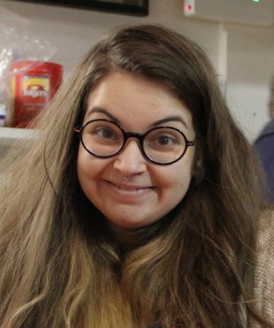

- Can you please tell me a little about yourself? How long have you lived in Sitka? What types of things are you involved in here?

I’m 24 and am ending my second year as SAFV’s AmeriCorps VISTA. I moved here from New Jersey shortly after receiving my B.S. in public health from Rutgers University. I am obsessed with baseball, music, books, sarcasm, and my dad, who is the greatest person I know. Most of what I am involved in here revolves around my job. I love it to the point where I enjoy learning more about my work and the movement outside of work… I just want to be the best I can be in the field of violence prevention, which is my passion. I am leaving Sitka soon to pursue my Masters in Public Health at Johns Hopkins University for 11 months. Following graduation, I will return to Sitka and SAFV to use my new skills and knowledge to help make Sitka a safer place.

- Do you have something you’d like to say to other women in Sitka?

Vernon Law said, “Experience is a hard teacher because she gives you the test first and the lesson afterward.” I have stumbled, fallen, and failed numerous times before, but the important part is that I have learned from it. I have grown and become the person I am today, and because of that, I try to embrace all of my experiences (the good, the bad, and everything in between) because without all of them, I would not be the person I am today, which I am extremely proud of. I guess what I am saying is don’t let what happens to you define you; let what you learn from what happens define you.

- What is your biggest struggle right now?

My biggest struggle right now is the upcoming transition from Sitka to Baltimore, especially since I only have a few days before my accelerated masters program begins. Also, I am going to miss Sitka and everyone here who makes it feel like home.

- What does a normal “Day in the Life” look like for you?

I am not a morning person, so when I first wake up, I have a fight with the snooze button. Then, I cuddle with my cat, Bud, and after twenty-five minutes of getting myself ready, I am off to work at SAFV. After work, I just do whatever I am in the mood for. If there is a Yankees game on, then I will usually find a place to watch it. If there is not, I might go for a walk, read a book, color, play with my cat, or enjoy a Netflix binge. After being busy all day, every day in college, it has been nice to live a calmer existence. Of course, that will all change again when I go to Baltimore.

- What makes you proud to be a woman?

All the women who have come before me make me proud to be a woman. A long time ago, women were seen as nothing more than property that could reproduce, but look how far we have come since then. Women have suffered and persevered time and time again, not just for themselves, but for all the women who came before them, those who stood next to them in battle, those they didn’t know, and those who were to come after them. It’s those women who have enabled women today to strive higher and girls to dream for more. I just hope that the women who come after me with feel the same, and given the amazing women who are breaking barriers today, I don’t think that will be a problem.

